Name _____________________________________________ Date _____________________________ Period ____
REVIEW: Energy and Heat
Determine which picture matches the energy transformations listed below.
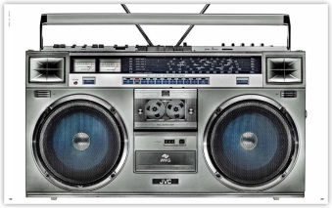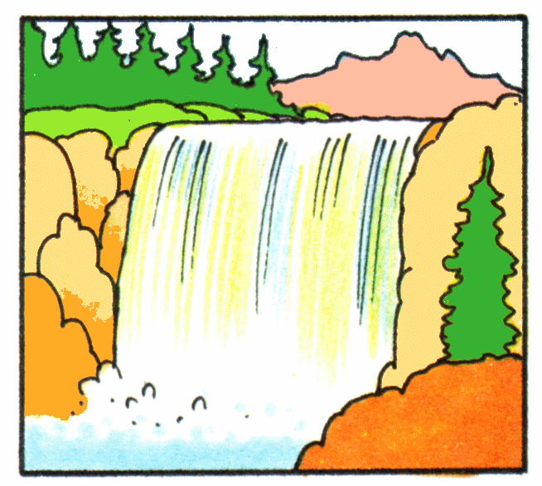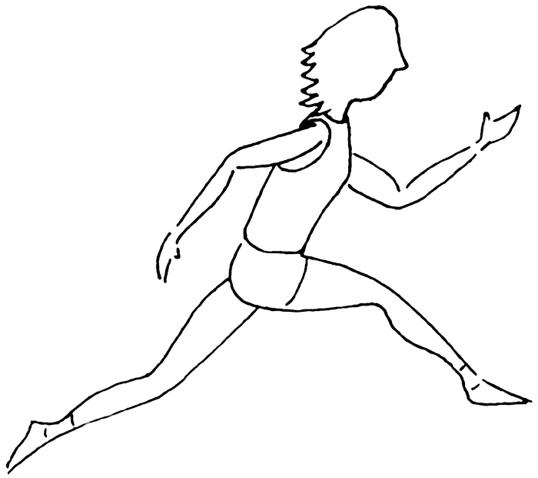

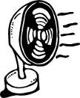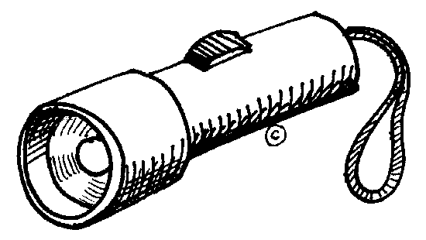
Energy Transformation | Object
Chemical energy radiant energy

Electrical energy mechanical energy

Chemical energy radiant energy and thermal energy
Mechanical energy sound energy

Electrical energy sound energy

Gravitational potential energy kinetic energy and sound energy
Electrical energy sound energy and radiant energy
Chemical energy mechanical energy and thermal energy
What energy transformation is taking place in each example below? Draw a picture to illustrate the transformation.
1. Dribbling a basketball | 2. Using a toaster
3. Walking to class | 4. Turning on a light

